ASSIGNMENT -II(Unit 1.2)

Name: Hamza Mohammad Asim

Employee # : 2303.KHI.DEG.014

Mate: Saad Sameer Khan (2303.KHI.DEG.034)
*we discussed together but attempted the assignments on own*

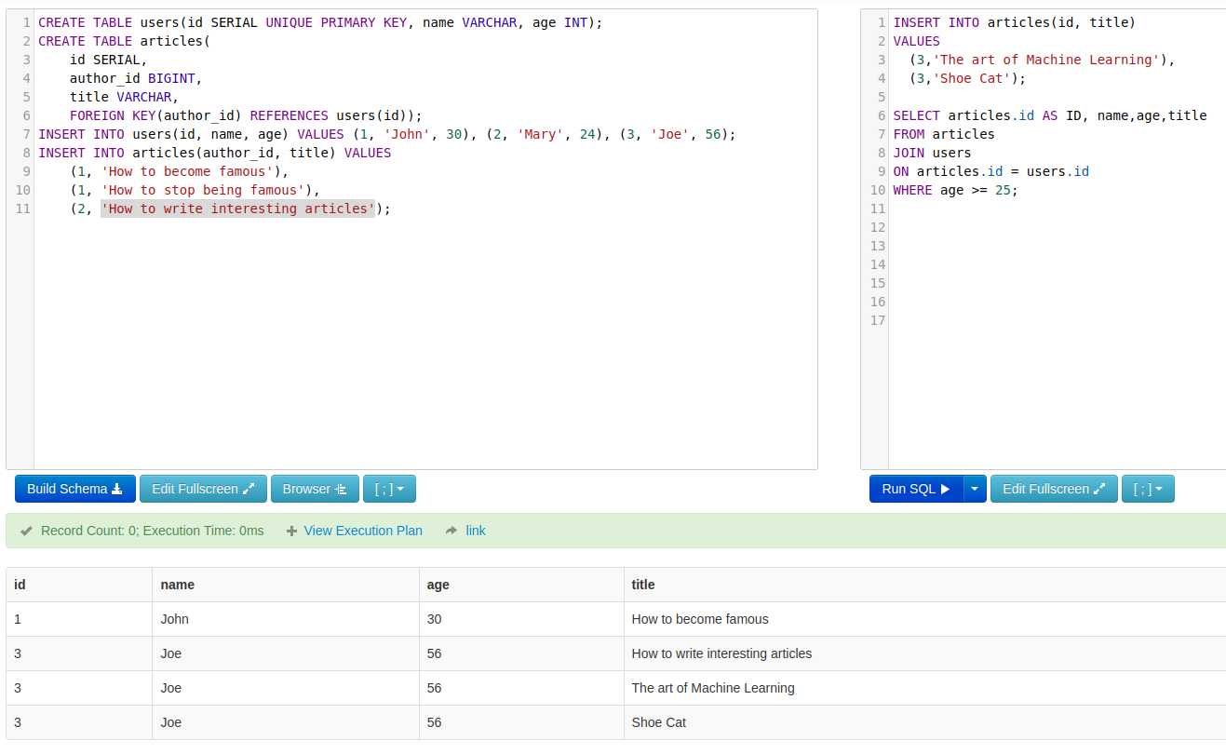

First four line of code inserts two more records in the ‘articles’ table, where id#3 is inserted with two book titles.

Line 6 – 10 is joining two different tables, ‘users’ and ‘articles’, with the help of a common column ‘id’. The results displaying on the query which I ran is by selecting ‘articles.id’ aliasing as ID, name, age, and title. The results were then filtered, using WHERE, out with age of 25 or above.

